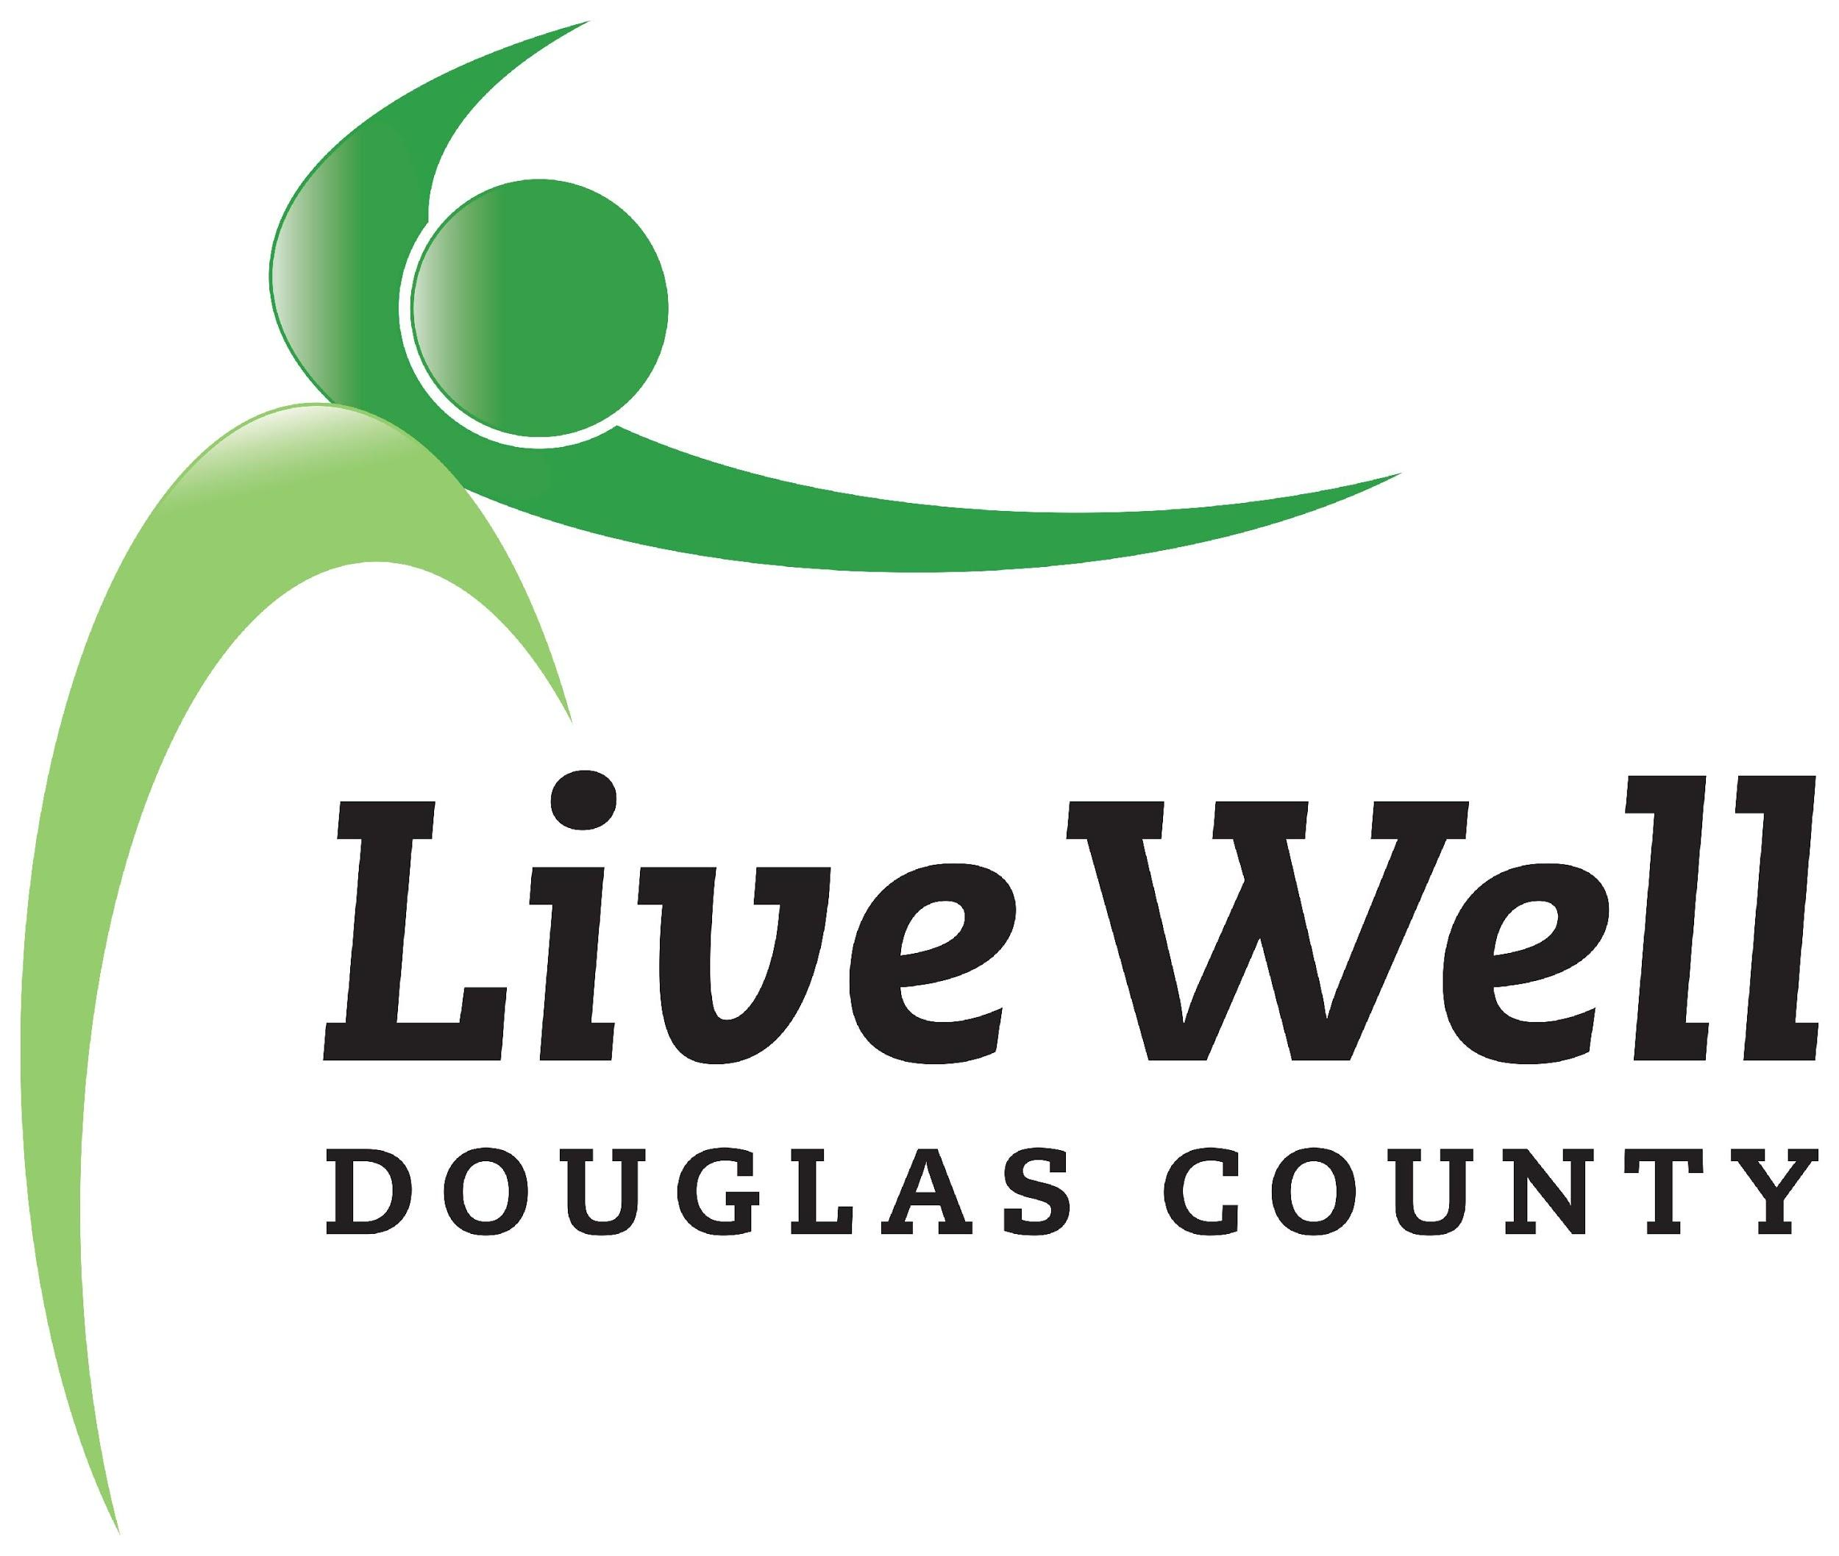
LiveWell Executive Team
Meeting Agenda

July 8, 2020, 3:30-5:00pm
Online via Zoom

Item | Notes | Action step
Review of agenda | - Any additions?
Transition | - Updates on funding commitments, follow up  - On-going projects
Recruitment strategy | - Review final position description  - Advertising, outreach
Equity | - Ways to incorporate meaningfully
Agenda for Leadership Meeting
Closing

Other potential items:

